Education Standards Board

SharePoint – Server Disk Space

Management Recommendation

20/07/2023

# Overview

* It was reported that disk space is low on the SharePoint Server

# Observations

* Disk free space is within normal static allowances (as shown below)
* Logging for applications and services is being stored on the C: which is not recommended and may be the cause of low disk space overtime
* A E: (Data drive) is available on the server, as a secondary drive to the C: (System drive)
* ISS Logging is being stored on the C:
* SharePoint Logging is being stored on the C:
* SharePoint Search Index is being stored on the C:

SCREENSHOT: Current disk space utilisation on SharePoint Server (EECSBWFE02)



# Recommendations

## Quick Wins

1. **Relocate IIS Logging to D: (Data Drive)**
   1. Current Storage usage on C: = **7GB**

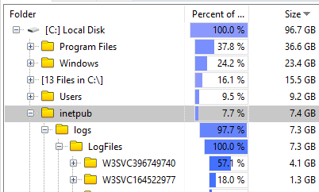

* 1. Change Impact: None
  2. Change Process
     1. Change Logging Location for web services in IIS
     2. Relocate existing logging files to D:

1. **Relocate SharePoint Logging to D: (Data Drive)**
   1. Current storage usage on C: = **20GB**

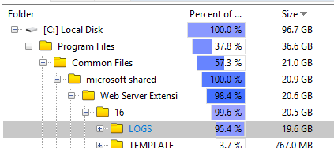

* 1. Change Impact: None
  2. Change Process
     1. Change Logging Location for
        1. SharePoint Diagnostic Logging
        2. SharePoint Usage and Health Monitoring
     2. Relocate existing log files to D:

## Large Change

1. **Relocate SharePoint Search Index Storage location to D: (Data Drive)**
   1. Current Storage usage on C: = **11GB**

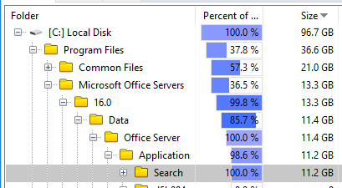

* 1. Change Impact: Search Service Outage (users won’t be able to perform Searching until index rebuilds itself in the new location – approx 20 hours)
  2. Change Process
     1. Modify Configuration of SharePoint search service
     2. Rebuild SharePoint search Index
     3. Test and confirm search is working as expected.